Software Release Certificate

PROJECT NAME: Denver EMU Project
This is to certify that all the deliverables for this software released for Site Acceptance have undergone Quality Assurance in accordance with the requirements laid down in the Contract and Software Quality Assurance Plan for the project. The list of deliverables for submission is exactly corresponded to the mentioned software version.

List of Software Items:
Item No. | Software Item | Version No. | Issue Date | Remark
1 | CRA-PAC | 1.0.05 | 3/20/2017
2 | CCP | 1.0.05 | 4/10/2017
3
4

List of Affected Software Documents:
Item No. | Document Name | Doc. No. | Issue Date | Target date for completion | Remark
1
2
3
4
5
6
7
8
9
10
11

I hereby confirm the newly released software is fit for on-site installation.  Subcontractor’s  Project Manager  Jae Young, Lee Signature 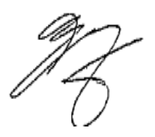 | Date: 9/20/2016

